**Sri Lanka Institute of Information Technology**



Final Project

MLB_04.01_04

Vehicle Insurance Management System

**IT1090 – Information System and Data Modeling (ISDM)**

B.Sc. (Hons) in Information Technology

**Group Details**

|  |  |  |  |  |
| --- | --- | --- | --- | --- |
|  | **Student ID** | **Student Name** | **Email** | **Contact**  **Number** |
| 1 | IT22316486 | HEWAGAMA A D | IT22316486@my.sliit.lk | 0761252976 |
| 2 | IT22336590 | SIRIWARDANA B J A | IT22336590@my.sliit.lk | 0775920586 |
| 3 | IT22887108 | KUMARAGE N D | IT22887108@my.sliit.lk | 0769963908 |
| 4 | IT22338334 | SHEHARA I G D S | IT22338334@my.sliit.lk | 0775265486 |
| 5 | IT22326904 | ALWIS D A C | IT22326904@my.sliit.lk | 0754538287 |

**Contents**

Hypothetical Scenario 4

Draft Requirement Analysis Document 5

Entity Relationship Model 6

Database Schema 7

Performance and Security Requirements 8

Sql Commands to Create Database 9 10 11 12

Sql Commands to Store data into database .13 14 15 16

Individual Contribution 17

Hypothetical Scenario

* **‘SAFE TRAVELS VEHICLE INSURANCE MANAGEMENT SYSTEM’** is selected as the topic of our group, we planned to develop an insurance system to manage their customer details, insurance details, claim details and documents through the system.
* First, unregistered user should register to the system by giving an email, password and NIC number. After registering, he/she will be a customer and that customer can login as a registered user with login credentials. customer can have one or more vehicles and for those vehicle/s, must have an insurance type. When a vehicle met with an accident, it needs to be claimed. For the claiming purpose, grade is offered to the claim by considering the accident and we can upload an image of the accident. After that purpose, claim is approving by the system manager and customer can get the claim status through the system. After that process done, system manager takes the value report. According to the report, customer can make the payments and for payments, there are various payment methods. Finally, after the customer is satisfied and done with all processes, customer can give feedbacks about the company and the system.

Draft Requirement Analysis Document

* System should accept customer registration and login if all the fields of required details filled correctly.
* System should give permission to modify profile details and reset passwords if forgot.
* Customers should be able to view Insurance details, category details through the system.
* System should create user account & store the user data in database.
* System should allow the customers to search insurance types.
* System should not accept the customers claim requests.
* System should allow the customer to select payment methods.
* System should allow the customer to select technical equipment, vehicle services and modifications they need as additional services.
* System should accept claim confirmation.
* System should display claim request summary with payment options.
* System should ask add card details to make the payment.
* System should display issued or rejected claim details.
* System should display that the customer should pay 10% of full payment as non-refundable payment as advance payment, when the registration of the vehicle.
* System should check correction of payment details and should display error messages for the incorrect details.
* System should accept payment confirmation.
* System should allow to process money transaction through banking system.
* System should display issued claim summary with deposit account details.
* System should allow customer to give feedbacks.
* System allows customers to cancel existing claim requests.
* System should allow to analyze financial reports to owner.
* System should allow to generate claim report, manage customer details, generate financial reports to administrative assistant.
* System should allow coordinator to check new registered vehicle details .
* System should allow banking system to validate the payment details

Entity Relationship Model

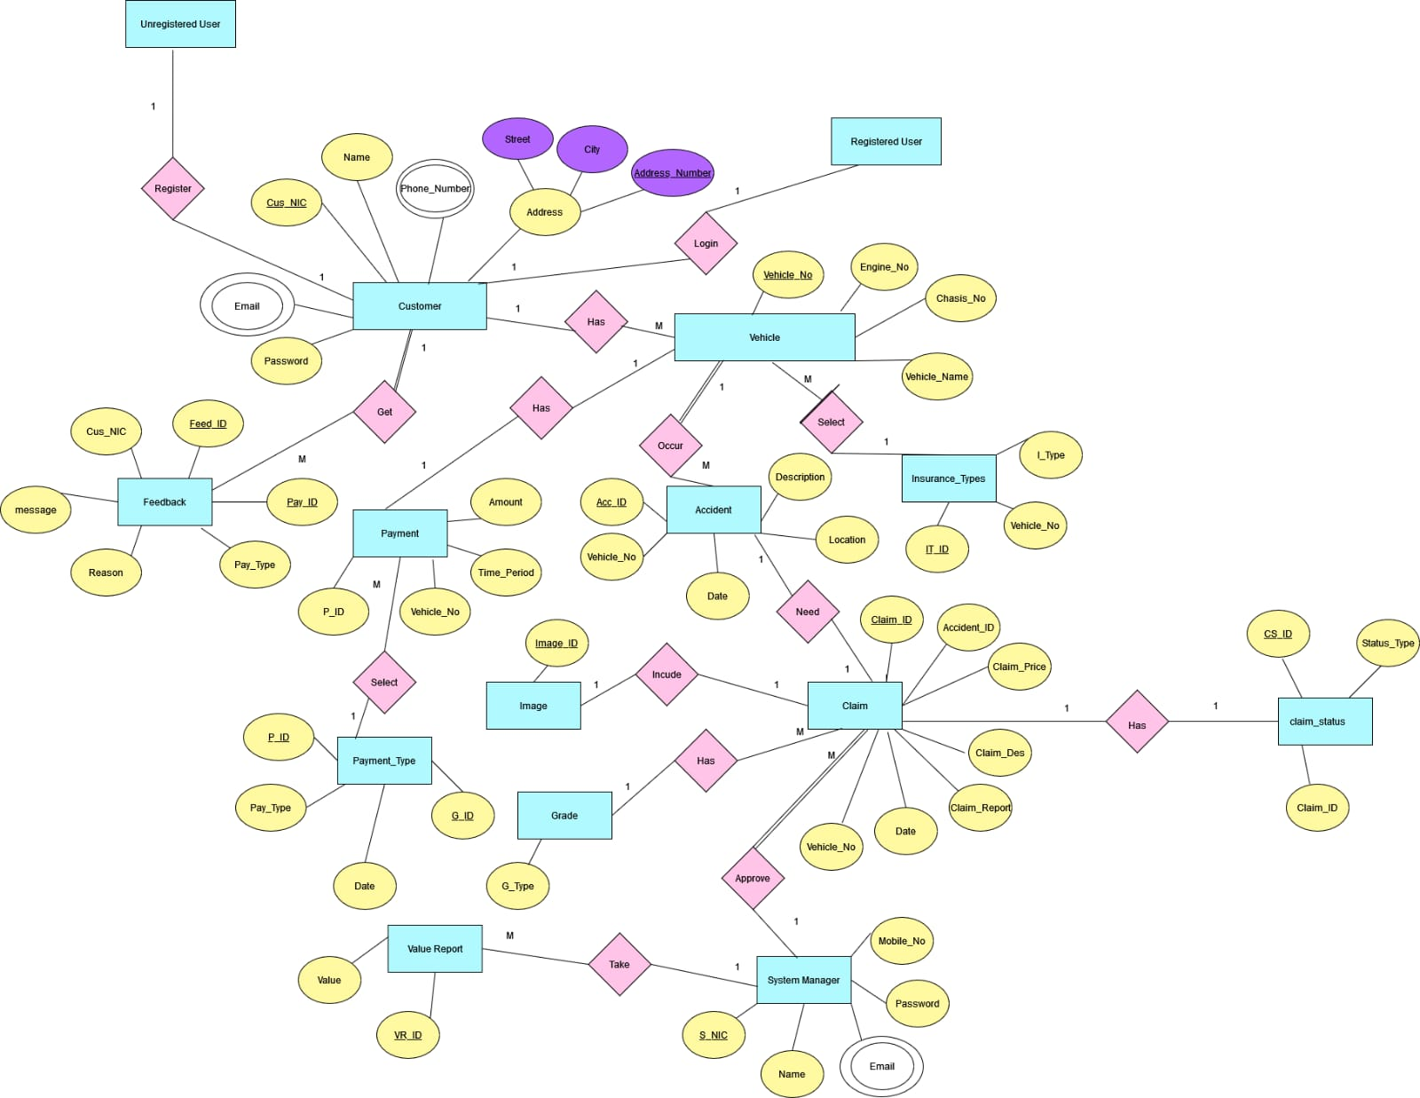

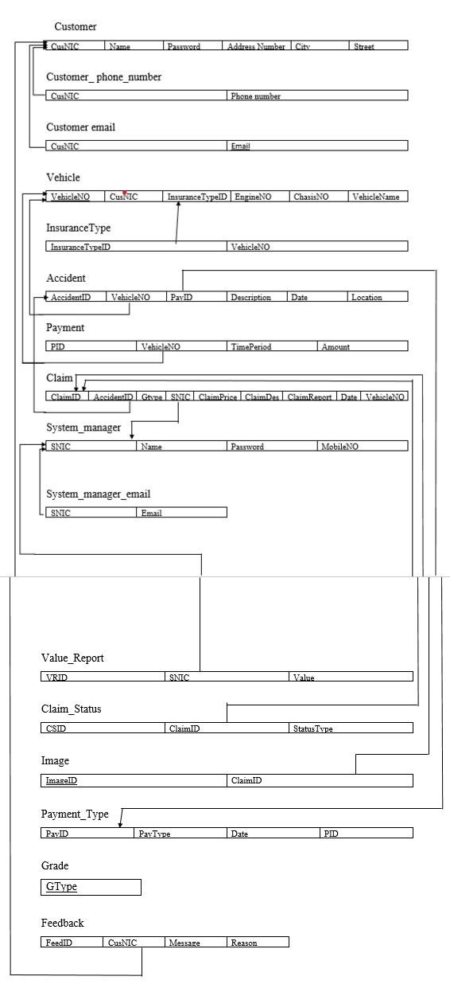Database Schema

Performance Requirements

* Registration and login process should be quick responsive and allow users to access their accounts without delays.
* Profile Updation and password reset functions should be efficient and should respond immediately to user requests.
* Retrieving insurance details and insurance catergory details should be fast by ensuring an absolute user experience.
* Creating user accounts and storing user data inside the database should be executed without any delay.
* Search functionality for insurance types should provide results quickly.
* Displaying claim request summaries, issued or rejected claim details, and financial reports should be created immediately to provide real-time information to users.
* Making money transactions through banking system should be fast and reliable to ensure payments.

Security Requirements

* User registration, login, and password reset processes should be secure by protecting user credentials and preventing unauthorized access.
* User profile details and sensitive information, such as payment details and deposit account information, should be encrypted and stored securely to maintain data confidentiality.
* Access to insurance details, insurance category information, and financial reports should be restricted to authorized personnel only with appropriate access controls.
* Payment confirmation and money transactions should be conducted securely, using encryption and secure protocols to protect sensitive financial data
* The system should have proper authentication and authorization mechanisms to ensure that only authorized users can access and perform specific actions inside the system.
* Data backups and recovery mechanisms should be implemented to prevent data loss and ensure system availability.
* The system should have measures to detect and prevent frauds, such as monitoring for suspicious activities, validating payment details with the banking system, and implementing fraud detection algorithms.

Sql Commands to Create Database

-- Table: Customer

CREATE TABLE Customer (

CusNIC VARCHAR(12) NOT NULL PRIMARY KEY,

Name VARCHAR(50),

Password VARCHAR(50),

Address_Number VARCHAR(10),

City VARCHAR(50) ,

Street VARCHAR(50)

);

-- Table: Customer_phone_number

CREATE TABLE Customer_phone_number (

CusNIC VARCHAR(12) NOT NULL,

Phone_Number VARCHAR(10) NOT NULL,

PRIMARY KEY (CusNIC, Phone_Number),

FOREIGN KEY (CusNIC) REFERENCES Customer(CusNIC)

);

-- Table: Customer_email

CREATE TABLE Customer_email (

CusNIC VARCHAR(12) NOT NULL,

Email VARCHAR(255) NOT NULL,

PRIMARY KEY (CusNIC, Email),

FOREIGN KEY (CusNIC) REFERENCES Customer(CusNIC)

);

-- Table: VehicleCREATE TABLE Vehicle (

VehicleNO VARCHAR(10) NOT NULL PRIMARY KEY,

CusNIC VARCHAR(12),

InsuranceTypeID VARCHAR(12),

EngineNO VARCHAR(50),

ChasisNO VARCHAR(50),

VehicleName VARCHAR(50),

FOREIGN KEY (CusNIC) REFERENCES Customer(CusNIC)

);

-- Table: Payment

CREATE TABLE Payment (

PID VARCHAR(10) NOT NULL PRIMARY KEY,

VehicleNO VARCHAR(10) NOT NULL,

TimePeriod VARCHAR(50) NOT NULL,

Amount DECIMAL(10, 2) NOT NULL,

FOREIGN KEY (VehicleNO) REFERENCES Vehicle(VehicleNO)

);

-- Table: Accident

CREATE TABLE Accident (

AccID VARCHAR(10) NOT NULL PRIMARY KEY,

VehicleNO VARCHAR(10) NOT NULL,

PayID VARCHAR(10) NOT NULL,

Description VARCHAR(255) NOT NULL,

Date DATE NOT NULL,

Location VARCHAR(100) NOT NULL,

FOREIGN KEY (VehicleNO) REFERENCES Vehicle(VehicleNO),

);

-- Table: System_manager

CREATE TABLE System_manager (

SNIC VARCHAR(12) NOT NULL PRIMARY KEY,

Name VARCHAR(50) NOT NULL,

Password VARCHAR(50) NOT NULL,

MobileNO VARCHAR(10) NOT NULL

);

-- Table: GradeCREATE TABLE Grade (

GTypeID VARCHAR(10) NOT NULL PRIMARY KEY,

GradeName VARCHAR(5)

);

-- Table: Claim

CREATE TABLE Claim (

ClaimID VARCHAR(10) NOT NULL PRIMARY KEY,

AccID VARCHAR(10) NOT NULL,

GtypeID VARCHAR(10) NOT NULL,

SNIC VARCHAR(12) NOT NULL,

ClaimPrice DECIMAL(10, 2) NOT NULL,

ClaimDes VARCHAR(255) NOT NULL,

ClaimReport VARCHAR(MAX) NOT NULL,

Date DATE NOT NULL,

FOREIGN KEY (AccID) REFERENCES Accident(AccID),

FOREIGN KEY (GTypeID) REFERENCES Grade(GTypeID),

FOREIGN KEY (SNIC) REFERENCES System_manager(SNIC)

);

-- Table: Value_Report

CREATE TABLE Value_Report (

VRID VARCHAR(10) NOT NULL PRIMARY KEY,

SNIC VARCHAR(12) NOT NULL,

Value DECIMAL(10, 2) NOT NULL,

FOREIGN KEY (SNIC) REFERENCES System_manager(SNIC)

);

-- Table: System_manager_email

CREATE TABLE System_manager_email (

SNIC VARCHAR(12) NOT NULL,

Email VARCHAR(255) NOT NULL,

PRIMARY KEY (SNIC, Email),

FOREIGN KEY (SNIC) REFERENCES System_manager(SNIC)

);

-- Table: Claim_Status

CREATE TABLE Claim_Status (

CSID VARCHAR(10) NOT NULL PRIMARY KEY,

ClaimID VARCHAR(10) NOT NULL,

StatusType VARCHAR(50) NOT NULL,

FOREIGN KEY (ClaimID) REFERENCES Claim(ClaimID)

);

-- Table: Payment_Type

CREATE TABLE Payment_Type (

PayID VARCHAR(10) NOT NULL PRIMARY KEY,

PayType VARCHAR(50) NOT NULL,

Date DATE NOT NULL,

--FOREIGN KEY (PID) REFERENCES Payment(PID)

);

-- Table: Feedback

CREATE TABLE Feedback (

FeedID VARCHAR(10) NOT NULL PRIMARY KEY,

CusNIC VARCHAR(12) NOT NULL,

Message VARCHAR(MAX) NOT NULL,

Reason VARCHAR(255) NOT NULL,

FOREIGN KEY (CusNIC) REFERENCES Customer(CusNIC)

);

-- Table: Image

CREATE TABLE Image (

ImageID VARCHAR(10) NOT NULL PRIMARY KEY,

ClaimID VARCHAR(10) NOT NULL,

FOREIGN KEY (ClaimID) REFERENCES Claim(ClaimID)

);

Sql Commands to Insert Data into Database

-- Customer

INSERT INTO Customer (CusNIC, Name, Password, Address_Number, City, Street)

VALUES

('123456789012', 'John Doe', 'password123', '123', 'New York', 'Main Street'),

('234567890123', 'Jane Smith', 'pass123', '456', 'Los Angeles', 'First Avenue'),

('345678901234', 'Mike Johnson', 'mikepass', '789', 'Chicago', 'Park Street'),

('456789012345', 'Emily Davis', 'emilypwd', '567', 'San Francisco', 'Broadway'),

('567890123456', 'David Wilson', 'david123', '901', 'Houston', 'Oak Drive');

-- Customer_phone_number

INSERT INTO Customer_phone_number (CusNIC, Phone_Number)

VALUES

('123456789012', '0754567890'),

('234567890123', '0715678901'),

('345678901234', '0766789012'),

('456789012345', '0787890123'),

('567890123456', '0708901234');

-- Customer_email

INSERT INTO Customer_email (CusNIC, Email)

VALUES

('123456789012', 'johndoe@yahoo.com'),

('234567890123', 'janesmith@gmail.com'),

('345678901234', 'mikejohnson@hotmail.com'),

('456789012345', 'emilydavis@yandex.com'),

('567890123456', 'davidwilson@protonmail.com');

-- Vehicle

INSERT INTO Vehicle (VehicleNO, CusNIC, InsuranceTypeID, EngineNO, ChasisNO, VehicleName)

VALUES

('ABC123', '123456789012', 'InsType01', '1234567890', '9876543210', 'Sedan'),

('DEF456', '234567890123', 'InsType02', '0987654321', '5432109876', 'SUV'),

('GHI789', '345678901234', 'InsType01', '1357924680', '8642097531', 'Hatchback'),

('JKL012', '456789012345', 'InsType02', '2468013579', '9753180246', 'Convertible'),

('MNO345', '567890123456', 'InsType01', '9876543210', '0123456789', 'Truck');

-- System_manager

INSERT INTO System_manager (SNIC, Name, Password, MobileNO)

VALUES

('SNIC98765', 'Jane Smith', 'admin123', '0776543210'),

('SNIC87654', 'Mark Johnson', 'adminpass', '0765432109'),

('SNIC76543', 'Sarah Davis', 'adminpwd', '0754321098'),

('SNIC65432', 'Daniel Wilson', 'admin456', '0743210987'),

('SNIC54321', 'Jessica Thompson', 'admin789', '0732109876')

-- Grade

INSERT INTO Grade (GTypeID, GradeName)

VALUES

('GID001' , 'A'),

('GID002' , 'B'),

('GID003' , 'C');

-- Feedback

INSERT INTO Feedback (FeedID, CusNIC, Message, Reason)

VALUES

('FEED1', '123456789012', 'Great customer service!', 'Satisfied with claim process'),

('FEED2', '234567890123', 'Need better communication', 'Delay in claim resolution'),

('FEED3', '345678901234', 'Smooth experience overall', 'Appreciation for timely updates'),

('FEED4', '456789012345', 'Unsatisfactory response', 'Lack of professionalism'),

('FEED5', '567890123456', 'Excellent coverage options', 'Positive feedback');

-- System_manager_email

INSERT INTO System_manager_email (SNIC, Email)

VALUES

('SNIC98765', 'janesmith@gmail.com'),

('SNIC87654', 'markjohnson@hotmail.com'),

('SNIC76543', 'sarahdavis@outlook.com'),

('SNIC65432', 'danielwilson@tunnelbear.com'),

('SNIC54321', 'jessicathompson@yahoo.com');

-- Value_Report

INSERT INTO Value_Report (VRID, SNIC, Value)

VALUES

('VRID01', 'SNIC98765', 1000.00),

('VRID02', 'SNIC87654', 1500.00),

('VRID03', 'SNIC76543', 800.00),

('VRID04', 'SNIC65432', 1200.00),

('VRID05', 'SNIC54321', 900.00)

-- Payment

INSERT INTO Payment (PID, VehicleNO, TimePeriod, Amount)

VALUES

('PID01', 'ABC123', '2023-05-01 to 2023-05-31', 100.00),

('PID02', 'DEF456', '2023-05-01 to 2023-05-31', 150.00),

('PID03', 'GHI789', '2023-05-01 to 2023-05-31', 200.00),

('PID04', 'JKL012', '2023-05-01 to 2023-05-31', 120.00),

('PID05', 'MNO345', '2023-05-01 to 2023-05-31', 180.00);

-- Accident

INSERT INTO Accident (AccID, VehicleNO, PayID, Description, Date, Location)

VALUES

('ACCID01', 'ABC123', 'PAY01', 'Minor collision', '2023-05-15', 'New York City'),

('ACCID02', 'DEF456', 'PAY02', 'Rear-end collision', '2023-05-17', 'Los Angeles'),

('ACCID03', 'GHI789', 'PAY03', 'Side collision', '2023-05-19', 'Chicago'),

('ACCID04', 'JKL012', 'PAY04', 'Hit and run', '2023-05-21', 'Houston'),

('ACCID05', 'MNO345', 'PAY05', 'Major accident', '2023-05-23', 'Miami');

--Claim

INSERT INTO Claim (ClaimID, AccID, GtypeID, SNIC, ClaimPrice, ClaimDes, ClaimReport, Date)

VALUES

('CLID01', 'ACCID01', 'GID001', 'SNIC98765', 2500.00, 'Damage to front bumper', 'Detailed claim report...', '2023-05-16'),

('CLID02', 'ACCID02', 'GID001', 'SNIC87654', 3500.00, 'Rear-end damage', 'Detailed claim report...', '2023-05-18'),

('CLID03', 'ACCID03', 'GID002', 'SNIC76543', 4500.00, 'Side damage', 'Detailed claim report...', '2023-05-20'),

('CLID04', 'ACCID04', 'GID003', 'SNIC65432', 5500.00, 'Hit and run damage', 'Detailed claim report...', '2023-05-22'),

('CLID05', 'ACCID05', 'GID002', 'SNIC54321', 6500.00, 'Extensive damage', 'Detailed claim report...', '2023-05-24');

-- Claim_Status

INSERT INTO Claim_Status (CSID, ClaimID, StatusType)

VALUES

('CSID01', 'CLID01', 'Pending'),

('CSID02', 'CLID02', 'Approved'),

('CSID03', 'CLID03', 'Rejected'),

('CSID04', 'CLID04', 'Processing'),

('CSID05', 'CLID05', 'Pending');

-- Payment_Type

INSERT INTO Payment_Type (PayID, PayType, Date)

VALUES

('PAYID01', 'Credit Card', '2023-05-20'),

('PAYID02', 'PayPal', '2023-05-22'),

('PAYID03', 'Cash', '2023-05-24'),

('PAYID04', 'Cheque', '2023-05-26'),

('PAYID05', 'Bank Transfer', '2023-05-28');

-- Image

INSERT INTO Image (ImageID, ClaimID)

VALUES

('IMGID01', 'CLID01'),

('IMGID02', 'CLID02'),

('IMGID03', 'CLID03'),

('IMGID04', 'CLID04'),

('IMGID05', 'CLID05');

Individual Contribution

|  |  |  |  |
| --- | --- | --- | --- |
| 1 | IT22887108 | KUMARAGE N D | Draft Requirement Analysis Document/Performance and Security Requirements |
| 2 | IT22316486 | HEWAGAMA A D | Database Schema |
| 3 | IT22336590 | SIRIWARDANA B J A | Er Diagram |
| 4 | IT22326904 | ALWIS D A C | Database Creation and Insertion Queries |
| 5 | IT22338334 | SHEHARA I G D S | Hypothetical Scenario |